**1] Write an ALP to calculate sum of multi digit numbers**

**Program**

exit  equ 1

read  equ 3

write equ 4

stdin equ 0

stdout equ 1

%macro writenumber 2

    mov ecx, %1

    mov edx, %2

    mov ebx, stdout

    mov eax, write

    int 80h

%endmacro

%macro readnumber 2

    mov eax, read

    mov ebx, stdin

    mov ecx, %1

    mov edx, %2

    int 80h

%endmacro

section .data

    msg db "Enter n", 10

    len equ $ - msg

    msg1 db "Enter 1st number", 10

    len1 equ $ - msg1

    msg2 db "Enter 2nd number",10

    len2 equ $ - msg2

    sumMsg db "THE SUM IS ",10

    sumLen equ $ - sumMsg

    newline db 10

section .bss

    sum resb 100

    number resb 100

    number2 resb 100

    nodig resb 2

section .text

    global _start

_start:

    writenumber msg,len

    readnumber nodig,2

    writenumber msg1,len1

    readnumber number,100

    writenumber msg2,len2

    readnumber number2,100

    movzx ecx,byte[nodig]

    sub ecx,'0'

    mov esi,ecx

    dec esi

call add

writenumber sumMsg,sumLen

writenumber sum,100

writenumber newline,1

mov eax, exit

xor ebx, ebx

int 80h

add:

   mov al,[number+esi]

   mov bl,[number2+esi]

   adc al,bl

   aaa

   pushf

   or al,30h

   popf

   mov[sum+esi],al

   dec esi

   loop add

ret

**OUTPUT –**

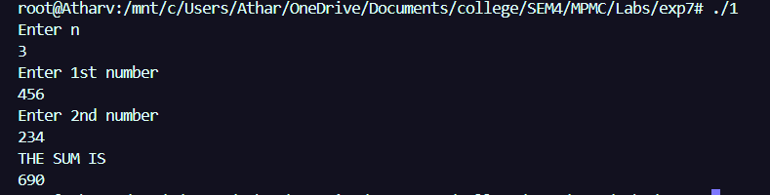

**2] Write an ALP to calculate difference of multi digit numbers**

**INPUT –**

exit  equ 1

read  equ 3

write equ 4

stdin equ 0

stdout equ 1

%macro writenumber 2

    mov ecx, %1

    mov edx, %2

    mov ebx, stdout

    mov eax, write

    int 80h

%endmacro

%macro readnumber 2

    mov eax, read

    mov ebx, stdin

    mov ecx, %1

    mov edx, %2

    int 80h

%endmacro

section .data

    msg db "Enter the size", 10

    len equ $ - msg

    msg1 db "Enter 1st number", 10

    len1 equ $ - msg1

    msg2 db "Enter 2nd number",10

    len2 equ $ - msg2

section .bss

    subno resb 100

    number resb 100

    number2 resb 100

    nodig resb 2

section .text

    global _start

_start:

    writenumber msg,len

    readnumber nodig,2

    writenumber msg1,len1

    readnumber number,100

    writenumber msg2,len2

    readnumber number2,100

    movzx ecx,byte[nodig]

    sub ecx,'0'

    mov esi,ecx

    dec esi

    call subb

    writenumber subno,100

    mov eax, exit

    xor ebx, ebx

    int 80h

    clc

    call subb

writenumber subno,100

 mov eax, stdout

 xor ebx, ebx

 int 80h

subb:

mov al,[number+esi]

   mov bl,[number2+esi]

   sbb al,bl

   aaa

   pushf

   or al,30h

   popf

   mov[subno+esi],al

   dec esi

   loop subb

ret

**OUTPUT –**

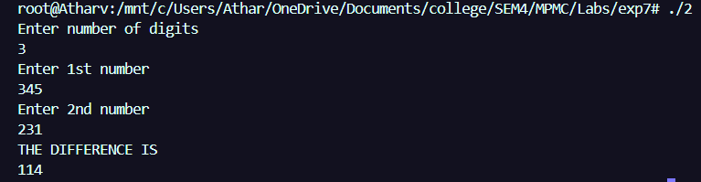

**CONCLUSION – THE SUM AND DIFFERENCE OF MULTI DIGIT NUMBERS WAS CALCULATED USING ALP**